Chapter 1

  - Introduction
Automatic Street Light is an Internet of Things (IoT) based project that is used to automatically control street lights depending on the surrounding light conditions. The main purpose of this system is to reduce electricity consumption and improve energy efficiency. In traditional street lighting systems, lights remain ON for the whole night even when they are not necessary, which leads to wastage of electricity.
In this project, a Raspberry Pi is used as the main controller to manage the system. An LED is used to represent the street light, and other components such as an Ethernet cable, adapter, breadboard, and jumper wires are used to connect and operate the circuit. The system works by detecting the surrounding light conditions and automatically turning the street light ON during the night and OFF during the daytime.
This project demonstrates how Raspberry Pi and electronic components can be used to build a smart and energy-efficient lighting system. Automatic street light systems are widely used in smart cities and help in saving energy and reducing manual effort.

1.2 Raspberry PI
A Raspberry Pi is a tiny, inexpensive computer. For less than $50, it includes all the components of a standard PC (processor, USB ports, etc.), runs various operating systems, and can be used in many projects (desktop usage but also electronics, robotics, retro-gaming, and more).
A Raspberry Pi is a single-board computer that’s about the size of a computer mouse (85 mm x 56 mm is the standard size). It looks like a PC motherboard, but all the components are already on it (CPU, memory, wireless module, USB, network, etc.).

- Why Was the Raspberry Pi Created?
The Raspberry Pi story started in 2006 with the creation of the first prototypes inspired by BBC Micro. Six years later, the Raspberry Pi was born. Its main goal was to help young people to discover computers at a low cost.
- How Does a Raspberry Pi Work?
A Raspberry Pi is a small computer, so it works the same way as any PC. An operating system (Linux in general) is installed on the SD card, and it can be connected to a monitor, keyboard and mouse to control it.

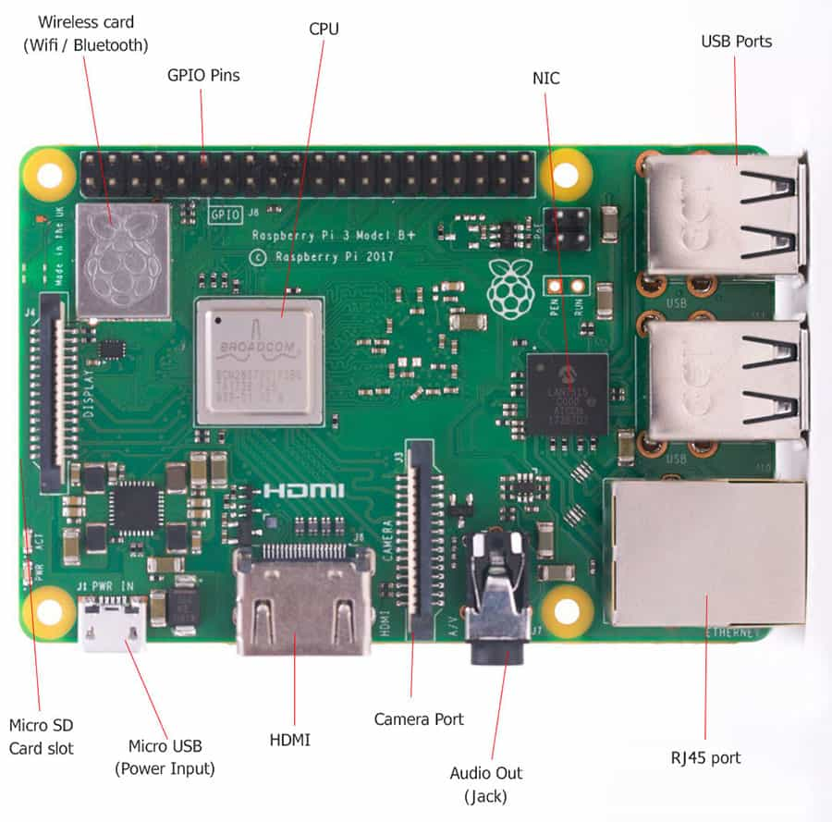
- USB ports: Recent models have 4 USB ports, 2x USB 3.0 (faster) and 2x USB 2.0 (to plug a keyboard and mouse for example).
- RJ45 port: Connect the Raspberry Pi to an Ethernet cable to get access to the Internet.
- Audio: It’s an output port for speakers, but you can’t plug a micro into it.
- HDMI: This can be a normal HDMI output or other variants, depending on the model. The Raspberry Pi 4B even has two outputs (to use dual monitors).
- Power supply: a Raspberry Pi is typically powered via USB. The connector is also different based on the model you have, but it basically works with a phone charger.
- Micro SD card slot: I already talked about this earlier. It’s on the back of the main board, and you can use similar cards as in your camera or smartphone (micro-SD format).
- Wireless card: Most models can use Wi-Fi and Bluetooth.
- Processor: Obviously, there’s a CPU on it, like on any computer. It’s a different architecture (ARM), which means not all systems can run on it, but it works the same way as on any PC.
- Memory: Raspberry Pi comes with RAM, starting from 256 MB on the oldest model to 8 GB on the most powerful. About 4GB to 8GB is what you typically get on a laptop nowadays, so it’s pretty good.
- Use of Raspberry Pi in Automatic Street Light
Raspberry Pi is used as the main controller in the Automatic Street Light system. It controls the operation of the street light based on the program written in it. The Raspberry Pi is connected to the LED light using jumper wires and a breadboard.
In this project, the Raspberry Pi sends signals to the LED light to turn it ON or OFF automatically. The LED represents the street light in the project model. When the system runs, the Raspberry Pi processes the program and controls the light without manual operation.
Thus, Raspberry Pi plays an important role in managing the Automatic Street Light system and helps in making the lighting process automatic and energy efficient.

  - Ethernet Cable
An Ethernet cable is a type of network cable that is used to connect devices such as computers, routers, and Raspberry Pi to a local area network (LAN). It helps in transmitting data between devices through a wired connection. Ethernet cables are commonly used for providing stable and fast internet connectivity.
An Ethernet cable is a physical medium that connects devices within a local area network (LAN). It transmits data between computers, routers, switches, and servers with high speed and reliability.
These cables are made from twisted pairs of copper wires that minimize interference. Most Ethernet cables utilize RJ45 connectors, which are compatible with standard networking ports.
Over time, Ethernet cable categories have evolved—from Cat5 to Cat8—each offering enhanced speeds, improved shielding, and improved performance.

- How Do Ethernet Cables Work?
An Ethernet cable uses twisted pair wiring to transfer data between devices with pinpoint speed and precision. These twisted pairs help reduce interference, allowing for stable and reliable communication.
Shielded cables are especially useful in environments exposed to high levels of electromagnetic interference, while unshielded ultra-thin cables are better suited for everyday home or office use.
Signal strength depends on both the quality and length of the cable—shorter distances typically ensure better performance. Ethernet cables also support full-duplex communication, allowing data to flow in both directions simultaneously without causing delays.

- What Are the Different Types of Ethernets Cables?
Commonly referred to as the most widely used network cable types, Ethernet cables vary in speed, shielding, and application. Below are the basics and appropriate uses for each category.
Cat5
The Cat5 cable is now considered obsolete and is typically found only in older installations. It supports speeds up to 100 Mbps with a bandwidth of 100 MHz. The maximum recommended length is 100 meters in standard environments. It lacks shielding and is primarily an unshielded twisted pair (UTP)
While it once served as the foundation for early network setups, Cat5 no longer meets the performance needs of modern systems.
Cat5e
The "e" stands for "enhanced," offering improved performance over Cat5. It supports speeds up to 1 Gbps and operates within a 100 MHz frequency range. Like Cat5, it performs well over distances up to 100 meters.
Tighter twists in the wires reduce crosstalk, although the cable is still mainly UTP. Cat5e
remains one of the most versatile and cost-effective Ethernet cable types for both home and office networks.
Cat6
Cat6 cables support higher speeds and improved signal quality. They offer 1 Gbps performance over 100 meters and up to 10 Gbps over shorter distances (up to 55 meters). With a bandwidth of 250 MHz, they efficiently handle heavier data loads.
Cat6 cables can be UTP or include some shielding to minimize interference. Among the various types of Ethernet cable, Cat6 strikes a solid balance between performance and cost.
Cat6a
An advanced version of Cat6, Cat6a (augmented), provides enhanced shielding and insulation. It supports 10 Gbps speeds across the full 100-meter length, with bandwidth extended to 500 MHz. Due to its complete shielding, Cat6a is ideal for environments prone to electrical interference, such as office floors or high-performance gaming setups. It stands out as one of the most balanced categories of Ethernet cables available in today’s market.
Cat7
Cat7 cables take things further with even more advanced shielding and performance. They offer up to 10 Gbps transmission across 100 meters and reach bandwidths up to 600 MHz. These cables use S/FTP shielding, which protects both against external interference and between internal wire pairs.
Instead of standard RJ45 connectors, Cat7 often uses GG45 or TERA connectors. This type is ideal for heavy-duty requirements and multitasking environments.
Cat8
Designed for data centers and backbone connections, Cat8 supports ultra-fast networking up to 40 Gbps over a maximum distance of 30 meters. It boasts a generous 2000 MHz bandwidth, making it suitable for high-volume data applications.

- What Are the Main Uses of Ethernet Cables?
- Home use: smart TVs, gaming consoles, PCs
An Ethernet cable provides a stable and fast connection at home. This setup helps reduce lag during online gaming and prevents buffering when streaming high-definition content. Smart TVs perform better when connected via Ethernet, offering smoother media playback.
Gaming consoles benefit from low latency and fewer disconnections. File transfers are also quicker on PCs with a direct Ethernet link. This is an ideal solution for users seeking reliable and nearly flawless internet performance, especially when selecting the right Ethernet cable types for home setups.
Office: workstations, VoIP phones, printers
Offices require dependable connections for day-to-day operations. Ethernet cables enable seamless VoIP calls, faster printing, and efficient file sharing across multiple workstations. This wired solution reduces wireless interference, enhancing overall productivity in collaborative work environments.
The broad range of Ethernet cable categories available ensures businesses can select the most suitable option based on bandwidth needs.
Industrial: control systems, manufacturing
In manufacturing environments, cables must perform reliably under harsh conditions. Ethernet connects control systems to machinery, requiring highly accurate and fast communication between units. Using shielded network cable types helps prevent interference, ensuring operational stability. Industrial setups demand durable cables that maintain performance under pressure, critical for both safety and precision.
Data centers: servers, switches, routers
Data centers rely on structured, wired infrastructures. Ethernet connects servers, switches, and routers to handle large volumes of data efficiently. High-bandwidth cables support simultaneous operations across multiple systems. Choosing the right types of Ethernet cable helps eliminate network bottlenecks, with each connection playing a key role in ensuring uptime and performance.
Use of Ethernet Cable in Automatic Street Light
In the Automatic Street Light project, the Ethernet cable is used to connect the Raspberry Pi to a network device such as a router or modem. This connection allows the Raspberry Pi to access the local network or the internet if required.
The Ethernet cable provides a stable and reliable wired connection between the Raspberry Pi and the network. Compared to wireless connections, Ethernet connections are generally faster and more stable. This helps the Raspberry Pi perform its tasks without interruption.
In this project, the Raspberry Pi acts as the main controller of the system. The Ethernet cable ensures that the Raspberry Pi remains connected to the network so that it can communicate with other devices or perform network-related operations if needed. Therefore, the Ethernet cable plays an important role in providing a secure and continuous network connection for the Automatic Street Light system.

  - Adapter
An adapter is an electronic device that is used to convert electrical power from one form to another so that it can be safely used by electronic devices. Most electronic devices require a specific voltage and current to operate properly. The adapter converts the high voltage from the main power supply into a lower and more stable voltage suitable for the device.
Adapters are commonly used to power devices such as laptops, mobile phones, routers, and Raspberry Pi. They ensure that the device receives the correct amount of power required for its operation. Without an adapter, electronic devices may get damaged due to high voltage.
Functions of the Adapter
- The adapter's function is to convert AC power into a single DC voltage that your computer can use.
- It functions as an external battery for your computer, reducing the need for a massive computer.
- A computer requires a wide range of DC voltages. The computer's internal circuits supply one, while the power adapter provides the other. The computer gets what it needs from these together.
- An adapter is hooked into a computer; it acts like a battery, giving it the precise voltage and energy it needs.
Types of Adapters
- Software adapters: In software, an adapter is a piece of code that conforms to an existing component's interface while utilizing a different implementation.
- Computer adapters: A host controller establishes a connection between a computer and an external device, like a network, storage, or human interface device.
- AC-to-DC adapters: An AC-to-DC power supply adapts electricity from household mains voltage (either 120 or 230 volts AC) to low-voltage DC suitable for powering consumer electronics.
- Travel Adapters: Passive electric power adapters, often known as travel plugs or adapters, enable the use of plugs from one area with sockets from another.
- Resource adapters: Numerous integration products come with resource adapters that grant for data conversion and the detection of adapter-specific behavior on various systems and data.
- Type C Plug Adapter: Type -C Plug Adapter, peripheral USB device communication is feasible at USB 3.1 power output speeds. This capacity backs thinner, smaller devices and can deliver 100W of power, which is satisfactory for most laptops.
- Type A Plug Adapter: Two parallel, flat pins or blades are used in the Type A adaptor. On smaller devices that don't need a ground connection, it may be initiated over the superiority of North America and the east coast of South America.
- Use of an Adapter in an Automatic Street Light

- In the Automatic Street Light project, the adapter is used to provide a power supply to the Raspberry Pi. The Raspberry Pi requires a stable and suitable voltage to operate properly, and the adapter helps in converting the main electrical power into the required voltage.
- The adapter supplies continuous power to the Raspberry Pi so that it can run the program and control the system. Without a proper power supply, the Raspberry Pi and other connected components cannot function correctly.
- In this project, the adapter ensures that the Raspberry Pi works continuously and controls the LED street light system automatically. Therefore, the adapter plays an important role in providing a stable power source for the Automatic Street Light system.
1.5 LDR SENSOR MODULE
A light sensor is a device that detects light and converts it into an electrical signal. You encounter them dozens of times a day, often without realizing it: the phone that dims its screen in a dark room, the automatic headlights on your car, the pulse oximeter clipped to your fingertip at a doctor’s office. At their core, all light sensors work on the same principle. When photons (particles of light) hit certain materials, they knock electrons loose, creating a flow of electricity that can be measured.
How do light sensors work?
The light sensor's working principle is based on the photoelectric effect. The sensor uses photosensitive materials that can respond to the presence of light. These materials can be semiconductors, photoconductive materials, or photovoltaic materials. When light hits the photosensitive material, its electrical properties change. This change can manifest as a variation in resistance, the generation of current, or a change in voltage. The sensor then converts this change into an electrical signal.
The electrical signal generated by the light sensor is usually very weak and needs amplification. This is achieved through an internal amplifier within the sensor. The amplified signal can then be further processed to obtain useful information, such as light intensity or wavelength. The processed signal is then output in a form that can be read by other electronic components or systems.
Types of LDR Sensor
A light sensor is a general term for all optical sensors. It is a broad term that includes many types of sensors. Each type has unique functions and uses. We mainly introduce four main types of light sensors:
1. Photoresistive sensors
Photoresistor sensors are sensitive to visible light wavelengths, including infrared and ultraviolet wavelengths. When exposed to light, the resistance value of the measuring unit changes, and the change in value is proportional to the light intensity. The simplest electronic device in a photosensitive sensor is a photoresistor, which can sense the change in light and output a weak electrical signal. After amplification and processing by a simple electronic circuit, it can control the automatic switching of LED lamps.
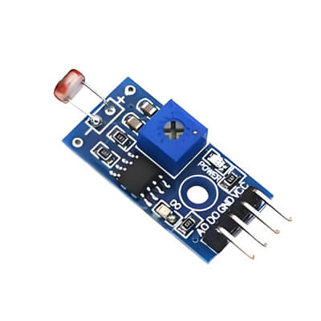
Photoresistor sensors are widely used in automatic control and household appliances, such as the brightness of televisions and the automatic exposure of cameras. Photoresistor sensors are cheap and simple in structure, but have slow response speed and low accuracy.
2. Photodiode sensors
When light strikes the PN junction of a photodiode, the light is absorbed and excites the production of electron and hole pairs, which generate an electric current, which is the working principle of a photodiode sensor. The output signal of the photodiode is proportional to the light intensity, and the signal conversion and measurement can be carried out by amplification and processing circuits.
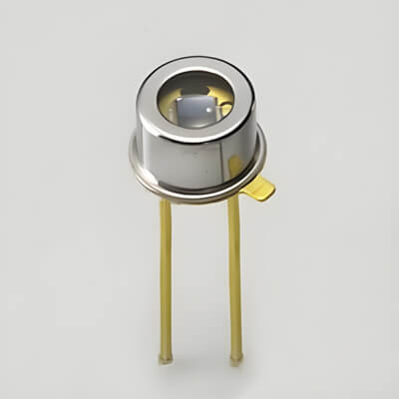
Photodiode sensors are commonly used in automation systems and industrial controls. For example, they can be used for component detection on automated assembly lines, label detection on packaging machinery, and robot positioning. It has a faster response time and higher accuracy than photodiode sensors. However, photodiode sensors are more expensive than photoresistive sensors.
3. Fiber-optic sensors
The working principle of the fiber optic sensor is to send the incident light source into the modulator through the optical fiber. After being processed by the modulator, the intensity, wavelength, frequency, phase, etc. of the light changes to become a modulated optical signal, thereby obtaining a specific value.
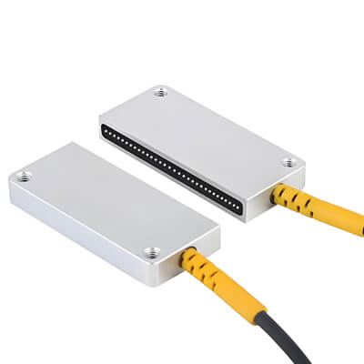
Fiber optic sensors have good electrical insulation performance, strong anti-interference ability, and high sensitivity. Easy to connect to the computer. It can be used for telephone, network broadband, and other digital model transmission. Widely used for automation equipment product positioning, counting, and identification.
4. Photoelectric effect sensors
The principle of this sensor is based on the photoelectric effect, the change of light into a light signal, and then, with the help of photoelectric components, to further convert the light signal into an electrical signal. It can detect non-electrical physical quantities that directly cause changes in the amount of light, such as light intensity and radiation temperature measurement. It can also detect other non-electrical quantities that can be converted into changes in the amount of light, such as the diameter of parts, surface roughness, and the shape of the object.
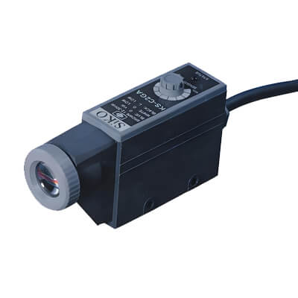
Photoelectric sensors have the characteristics of non-contact, fast response, reliable performance, etc., so they are widely used in industrial automation devices and robots.
Measuring the range of the light sensor
For outdoor environments, the light intensity can reach 60,000 to 100,000 lux in direct sunlight in summer. 1,000 to 10,000 lux outdoors without the sun. 100 to 550 lux in bright summer indoors, 0.2 lux at night under a full moon.
For indoor environments, incandescent lamps can emit about 12.56 lux per watt, but the value varies with the size of the bulb. Small bulbs can emit more lumens, large bulbs less. The luminous efficiency of fluorescent lamps is 3 to 4 times that of incandescent lamps.
Use of Light Sensor in Automatic Street Light
In the Automatic Street Light project, the light sensor is used to detect the surrounding light intensity. It helps the system determine whether it is daytime or nighttime.
When the light sensor detects a high level of light, which indicates daytime, it sends a signal to the Raspberry Pi to keep the street light OFF. When the light level becomes low, which indicates nighttime or darkness, the sensor sends a signal to the Raspberry Pi to turn the street light ON.
In this way, the light sensor automatically controls the operation of the street lights based on the surrounding light conditions. This helps in saving electricity and reduces the need for manual operation. Therefore, the light sensor plays a very important role in the Automatic Street Light system.
  - Jumper wire
What is a Jumper Wire?
A jumper wire is a short conductor with an insulated covering, used to connect two points in a circuit. They are designed to provide temporary or semi-permanent connections. Instead of permanently soldering components together, jumper wires allow you to quickly plug and unplug parts while testing or making changes. They usually come with connectors at their ends, such as male pins or female sockets, so they can easily fit into breadboards, headers, or modules. These wires are very flexible and reusable, making them a must-have accessory in any electronics kit.
Key Features of Jumper Wires
Jumper wires have certain features that make them ideal for electronic projects:
- Good Conductivity: Made of copper or tinned copper, ensuring smooth current flow.
- Durable Insulation: Coated with PVC or flexible plastic to protect from damage.
- Different Lengths: Common lengths are 10 cm, 20 cm, 30 cm, and more.
- Variety of Connectors: Available with male-to-male, male-to-female, or female-to-female pins.
- Color Coding: Usually comes in multiple colors such as red, black, yellow, blue, and green for easy identification.
- Reusable: Can be used many times across different projects.
Types of Jumper Wires
Based on the type of connector pins, jumper wires are classified into three main types:
- Male to Male Jumper Wire
  - Both ends have male pins.
  - Used mainly for breadboard-to-breadboard or breadboard-to-module connections.
- Male to Female Jumper Wire
  - One end has a male pin, and the other has a female socket.
  - Perfect for connecting sensors or modules that have female headers.
- Female to Female Jumper Wire
  - Both ends have female sockets.
  - Useful for connecting two modules or boards that have male pins.
By using the right type of jumper wire, you can make any connection required for your circuit without any difficulty.
Pin Configuration and Color Coding
Unlike microcontrollers or ICs, jumper wires don’t have a fixed pin configuration. Instead, the ends of the wires act as connectors. Male pins can be inserted into female headers or breadboards, while female sockets are used to receive male pins. To make connections easier, jumper wires are often color-coded. For example:
- Red: Power (Vcc)
- Black: Ground (GND)
- Yellow/Green/Blue: Signal lines
This color coding helps avoid mistakes while building circuits.
Applications of Jumper Wires
Jumper wires are extremely versatile and are used in countless electronic projects. Some common applications include:
- Building and testing circuits on breadboards.
- Connecting sensors, modules, and microcontrollers.
- Debugging hardware by quickly adding or removing connections.
- Making educational circuits for students and hobbyists.
- Creating quick prototypes without soldering.
- Extending the reach of circuit connections.

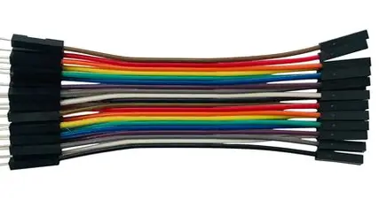

Use of Jumper Wire in Automatic Street Light
Jumper wires are used to connect different electronic components in the circuit. They help in transferring electrical signals and power between the Raspberry Pi, light sensor, LED, and breadboard.
In the Automatic Street Light project, jumper wires are used to create connections between all the components on the breadboard and the Raspberry Pi. These wires allow the sensor to send signals to the Raspberry Pi and help the Raspberry Pi control the LED that represents the street light.
Jumper wires make the circuit flexible and easy to assemble. They are very useful in electronic projects because they allow quick and reliable connections between devices.

  - Breadboard
A breadboard is an electronic device used to build and test circuits without soldering. It allows different electronic components such as sensors, LEDs, resistors, and microcontrollers to be connected easily using jumper wires.
A breadboard contains many small holes arranged in rows and columns. These holes are internally connected with metal strips that allow electrical signals to pass between components. By inserting component pins into these holes, a temporary circuit can be created and tested.
Types of Breadboards
It’s crucial to understand that not all breadboards are equal. They generally fall into two broad categories: solder and solderless.
Solderless Breadboards:
Solderless breadboards are what most beginners—and even seasoned tinkerers—reach for first. Why? Because they make trying out ideas fast and reversible. Components and jumper wires can be pushed into the tiny spring-loaded holes on the board to form a circuit, no permanent commitment needed.
It's like the dry-erase board of electronics: if something doesn’t work, just pull it out and try again. This is the kind of breadboard you’ll use for experimenting with an Arduino, testing an LED matrix, or mocking up a sensor system.
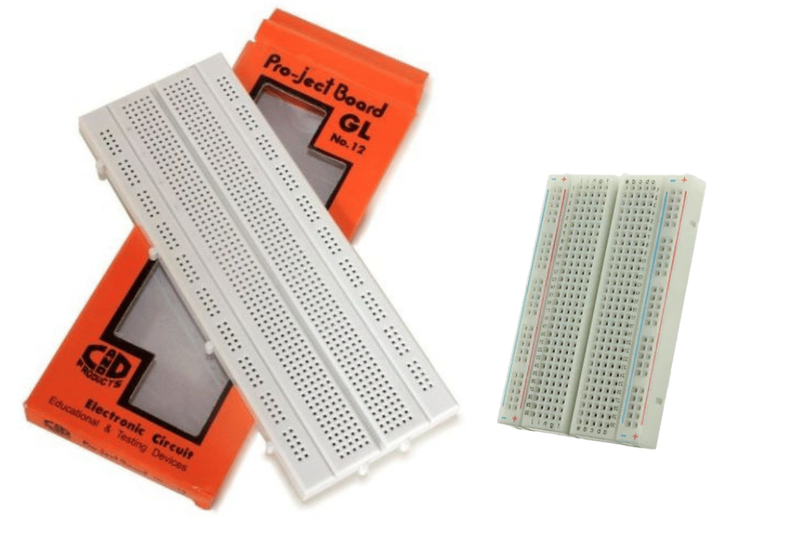
Solder Breadboards:
Once your circuit idea is solid and tested, you might want to make it more permanent. This is when you use soldered breadboards. Here, you solder electronic components and wires directly to the board, locking your design into place.
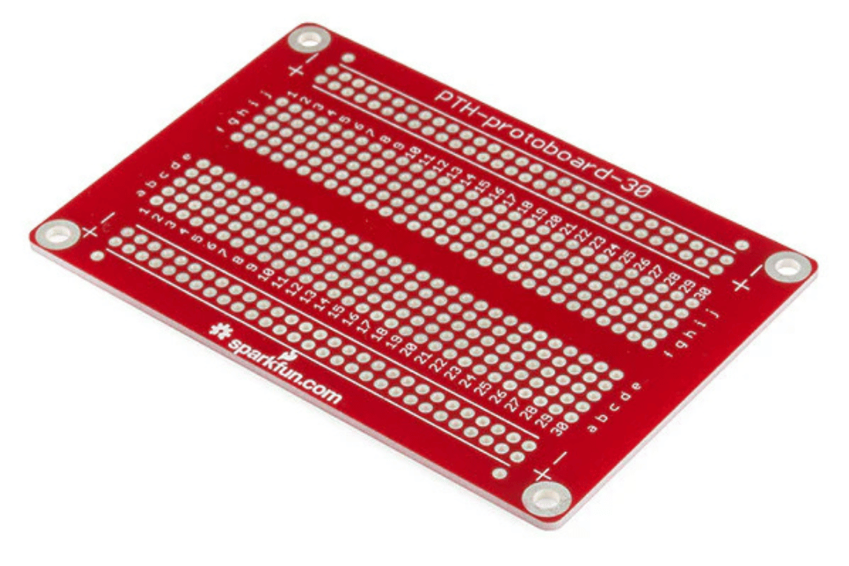

Use of Breadboard in Automatic Street Light
In the Automatic Street Light project, a breadboard is used to build and organize the electronic circuit. A breadboard allows different electronic components to be connected without soldering, which makes the circuit easy to build and modify.
The breadboard is used to connect the light sensor, LED, and Raspberry Pi with the help of jumper wires. It provides a convenient platform where all the components can be placed and connected properly. By using a breadboard, the circuit can be tested easily and changes can be made without damaging the components.
Therefore, the breadboard plays an important role in organizing the circuit and making the connections between different components in the Automatic Street Light system.
1.7 Led Light Sensor

